
National Textile University
Department of Computer Science
Project:
Fingerprint Attendance System
Submitted to:
Sir Nasir Mehmood
Submitted by:
Arooj Komal (23-NTU-CS-1140)
Ayesha Khalid (23-NTU-CS-1248)
Faseeha Ahmad (23-NTU-CS-1251)
Subject:
Embedded IoT Systems
Section:
BSAI
Semester:
5th
Contents
IoT Based Fingerprint Attendance System 3
Using ESP32, AS608 Fingerprint Sensor, Blynk, Node-RED and Google Sheets 3
1. Executive Summary 3
2. Introduction 3
3. Project Objectives 3
4. System Overview 3
4.1 System Architecture 3
4.2 Hardware Components 4
4.3 Software Components 4
4.4 Blynk Widget Configuration 4
4.5 Working Principle 4
4.6 Data Flow 5
4.7 Hardware Pin Connections 5
4.8 Circuit diagram 6
4.8 Advantages 6
4.9 Applications 6
5. Phase 1: Implementation Using Blynk 7
Libraries used: 7
Features Implemented: 7
Limitations of Blynk: 7
6. Phase 2: Implementation Using Node-RED 7
Advantages of Node-RED: 7
Node-RED Functions: 7
7. System Working Principle 8
8. Google Sheets Data Structure 8
9.Flowchart 9
10.Screenshots 10
11.Results and Observations 12
12. Testing and Validation 13
13. Conclusion 13
14. Future Enhancements 13

IoT Based Fingerprint Attendance System

Using ESP32, AS608 Fingerprint Sensor, Blynk, Node-RED and Google Sheets

1. Executive Summary
This project presents an IoT-based Fingerprint Attendance System that was implemented in two phases. In the first phase, the system was developed using the Blynk IoT platform for dashboard control and monitoring. In the second phase, the system was enhanced and migrated to Node-RED, providing greater flexibility, control, and customization.
The system uses an ESP32 microcontroller, AS608 fingerprint sensor, and OLED display to authenticate users biometrically and automatically record attendance. Attendance data is stored in Google Sheets with real-time date and time fetched via the internet (NTP). The final solution is secure, automated, and suitable for educational institutions and organizations.

2. Introduction
Traditional attendance systems are manual, time-consuming, and prone to errors such as proxy attendance. Biometric authentication provides a reliable solution by uniquely identifying each individual.
This project aims to design and implement an IoT-enabled fingerprint attendance system that records attendance automatically and stores it in the cloud. The project was first implemented using Blynk and later improved using Node-RED to overcome limitations and add advanced control.

3. Project Objectives
- To design a fingerprint-based attendance system
- To implement automatic enrollment of new users
- To authenticate users using biometric fingerprints
- To provide real-time feedback using OLED display
- To store attendance records automatically in Google Sheets
- To develop IoT dashboards using Blynk and Node-RED
- To prevent duplicate attendance entries on the same day

4. System Overview

4.1 System Architecture
The system consists of four main layers:
- Hardware Layer – ESP32, AS608, OLED
- Communication Layer – WiFi
- Cloud Layer – Blynk & Google Sheets
- User Interface Layer – Blynk Dashboard

4.2 Hardware Components

ESP32
Controls the system, manages WiFi, processes fingerprints, and sends data to the cloud.

AS608 Fingerprint Sensor
Used for fingerprint enrollment and authentication. Each fingerprint is stored with a unique ID.

OLED Display
Shows system status such as booting, WiFi connection, enrollment instructions, and attendance confirmation.

4.3 Software Components
- Blynk Platform: Dashboard control, status display, and user input
- Google Sheets: Cloud database for attendance records
- Arduino Framework: Used to program ESP32

4.4 Blynk Widget Configuration
Widget | Virtual Pin | Purpose
Enroll Button | V0 | Start enrollment
Attendance Button | V1 | Mark attendance
Status Label | V2 | Show system status
Name Label | V3 | Display user name
Name Input | V4 | Enter name for enrollment

4.5 Working Principle
- System powers ON
- ESP32 connects to WiFi
- User enters name in Blynk
- User presses Enroll
- Fingerprint is scanned and stored
- User presses Attendance
- Fingerprint is verified
- Attendance is uploaded to Google Sheets
- OLED shows confirmation

4.6 Data Flow
Fingerprint → ESP32 → WiFi → Blynk Cloud → Google Sheets → Dashboard

4.7 Hardware Pin Connections

AS608 Fingerprint Sensor → ESP32
AS608 Pin | ESP32 Pin
VCC | 5V
GND | GND
TX | GPIO 16
RX | GPIO 17

OLED Display (I2C) → ESP32
OLED Pin | ESP32 Pin
VCC | 3.3V
GND | GND
SDA | GPIO 21
SCL | GPIO 22

Power Summary
- ESP32: USB 5V
- AS608: 5V
- OLED: 3.3V

4.8 Circuit diagram
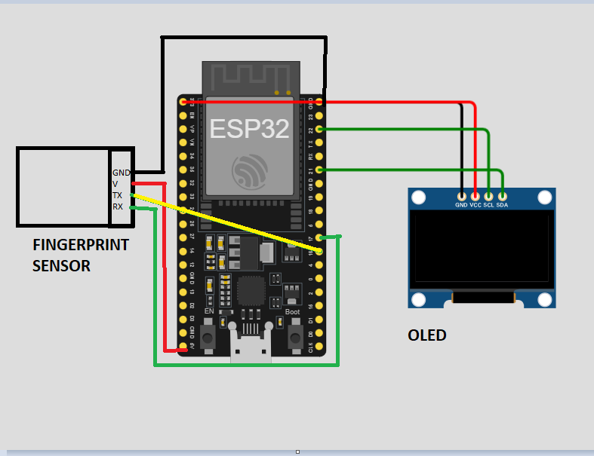

4.8 Advantages
- Automatic attendance
- Real-time monitoring
- Cloud storage
- Easy to use dashboard
- Reduced manual errors

4.9 Applications
- Schools
- Colleges
- Offices
- Training centers

5. Phase 1: Implementation Using Blynk
In the first phase, the project was implemented using the Blynk IoT platform.

Libraries used:
- adafruit/Adafruit Fingerprint Sensor Library
- adafruit/Adafruit SSD1306
- adafruit/Adafruit GFX Library
- blynkkk/Blynk

Features Implemented:
- Enroll button to register new users
- Text input widget for user name
- Attendance button to mark attendance
- OLED feedback messages
- Google Sheets integration

Limitations of Blynk:
- Limited widget customization
- Dependency on mobile application
- Less flexibility in logic handling
- Difficulty in handling complex workflows
Due to these limitations, the project was further enhanced using Node-RED.

6. Phase 2: Implementation Using Node-RED
In the second phase, Node-RED was used to replace Blynk as the dashboard and control interface.

Advantages of Node-RED:
- Fully customizable web dashboard
- Better control over logic and data flow
- Easier integration with Google Sheets
- Real-time visualization and debugging

Node-RED Functions:
- Trigger enrollment and attendance
- Display system status
- Prevent duplicate attendance
- Send data to Google Sheets

7. System Working Principle
- ESP32 connects to Wi-Fi
- Fingerprint sensor and OLED are initialized
- User enrolls fingerprint (two scans)
- Fingerprint ID is mapped to user name
- User scans finger for attendance
- ESP32 verifies fingerprint
- Date and time fetched using NTP
- Attendance sent to Google Sheets
- Duplicate attendance is prevented

8. Google Sheets Data Structure
Finger_ID | Name | Date | Time | Status
1 | Ali | 07-01-2026 | 09:15 | Present
Google Apps Script updates existing records if attendance is already marked for the day.

9.Flowchart
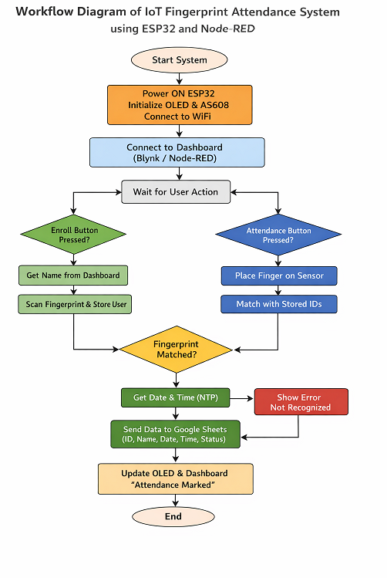

10.Screenshots
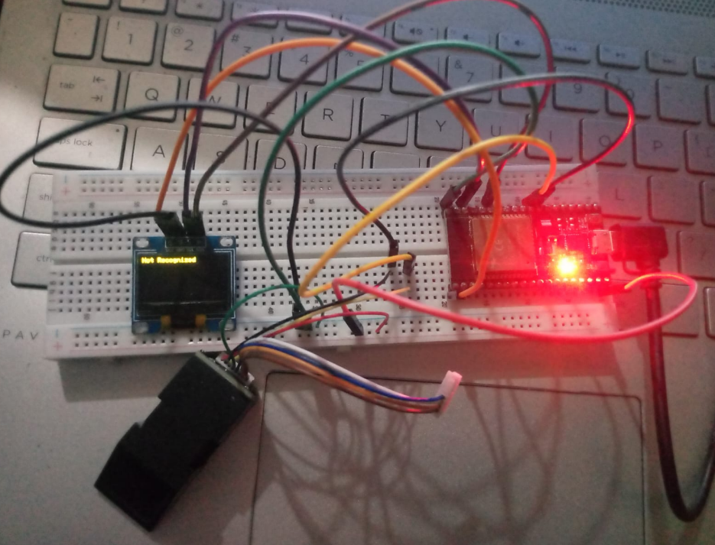
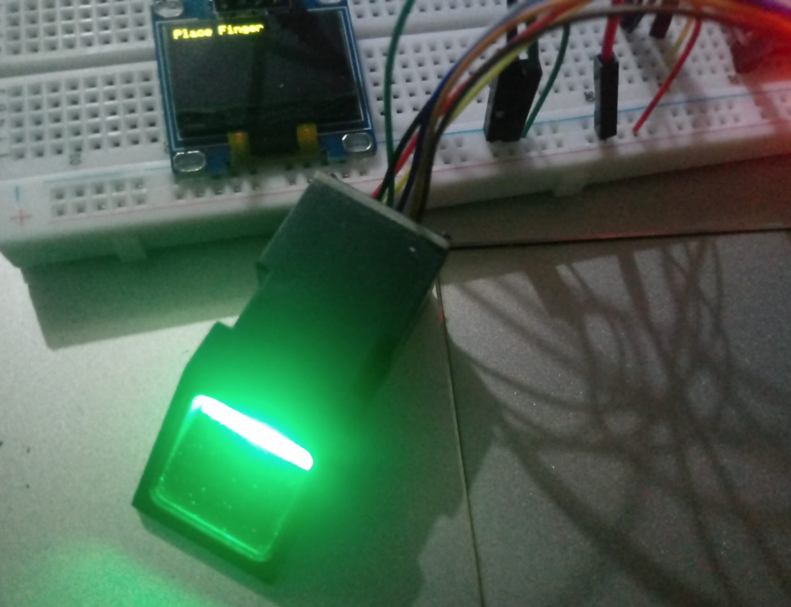
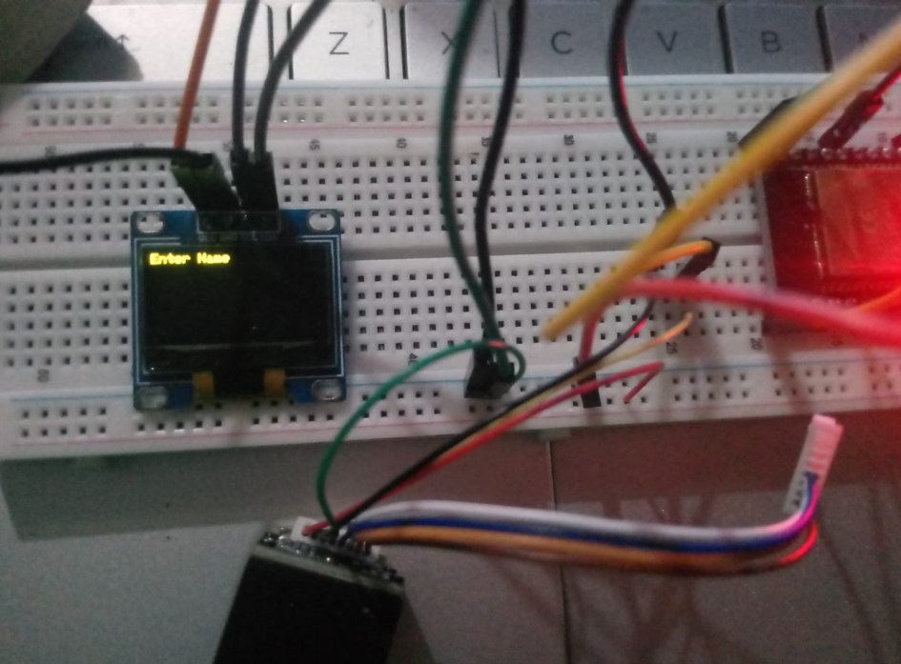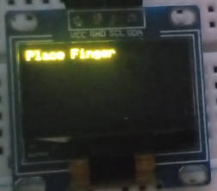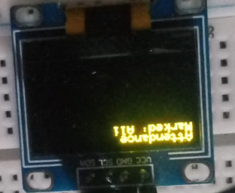
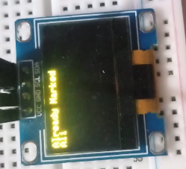
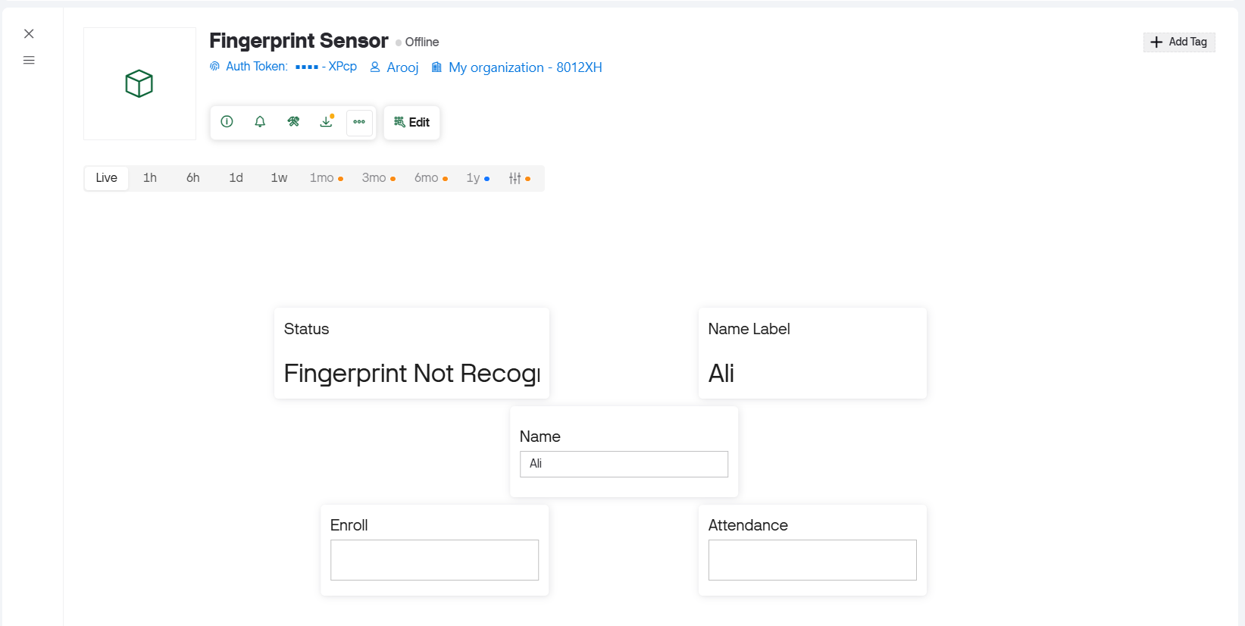

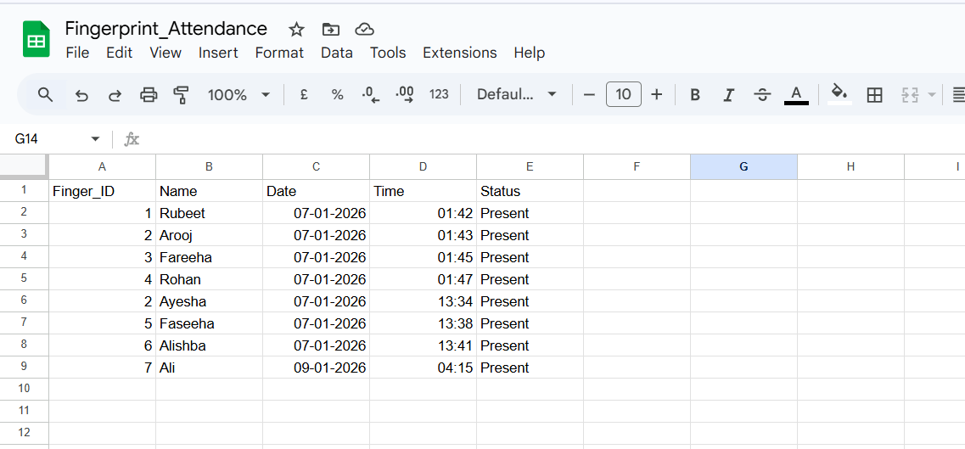

11.Results and Observations
- Accurate fingerprint authentication
- Real-time attendance logging
- Correct date and time from NTP server
- No duplicate attendance entries
- Smooth dashboard operation in Node-RED
- OLED provides clear user feedback

12. Testing and Validation
Test Case | Result
Valid fingerprint | Attendance marked
Same user twice | Duplicate prevented
Invalid fingerprint | Access denied
Wi-Fi disconnection | Auto reconnection
Power reset | System resumes

13. Conclusion
The IoT-based Fingerprint Attendance System successfully automates attendance management using biometric authentication and cloud storage. Implementing the project in two phases—first with Blynk and then with Node-RED—helped overcome platform limitations and improved system reliability and flexibility.

14. Future Enhancements
- Face recognition integration
- Offline attendance storage
- SMS / Email notifications
- Admin web portal
- Mobile application

